**Lab Practical #05:**

TryHackMe Room: - **DOS**

1. Here, we have two machine with name kali and kali2.

Ip address of kali is **192.168.56.101**

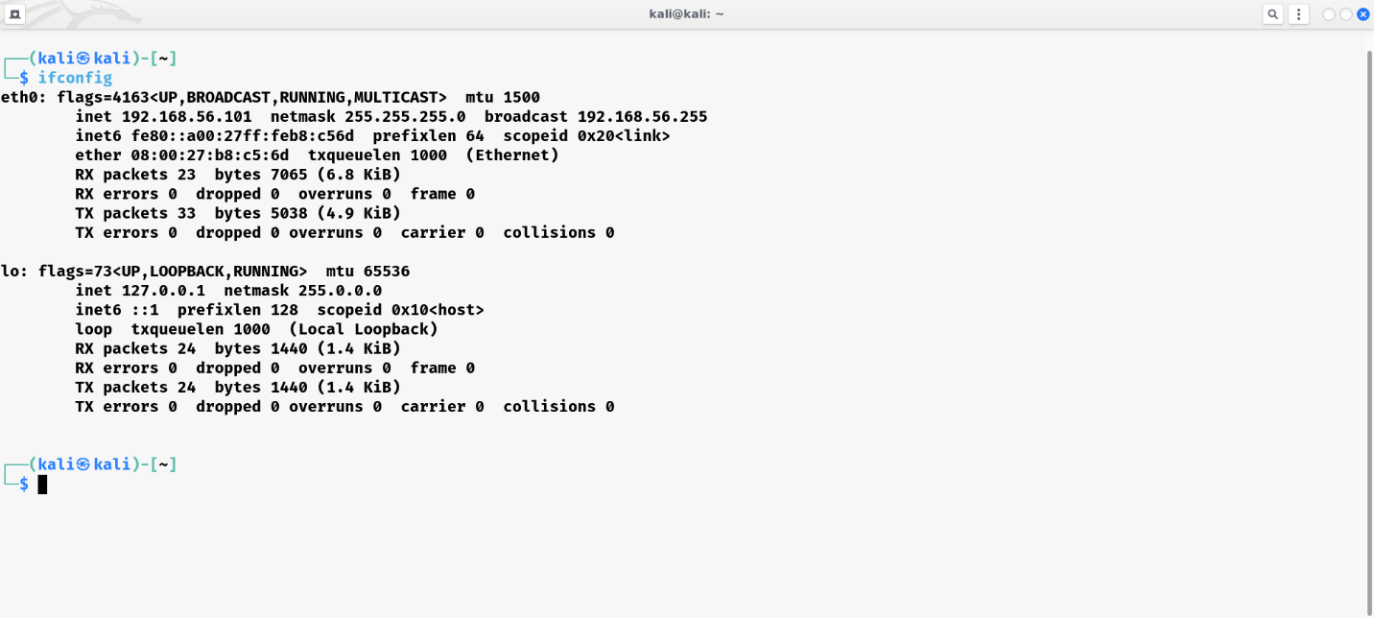

1. Ip address of kali2 is **192.168.56.102**

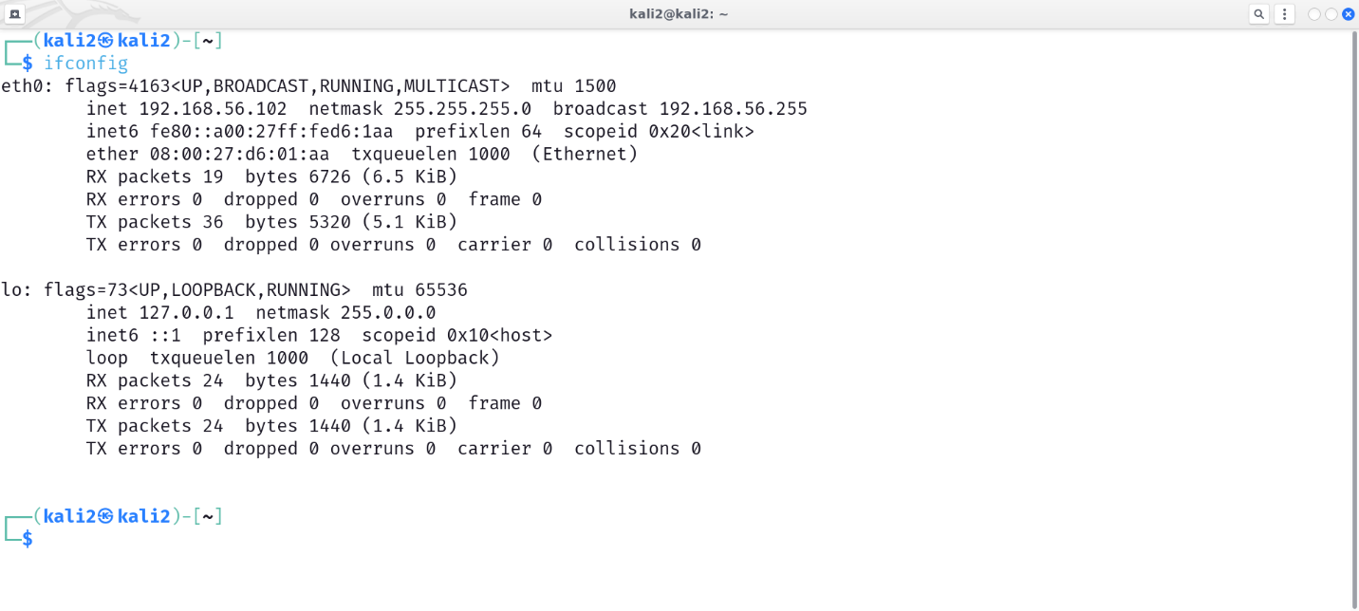

1. First of all we will send one packet from source **192.168.56.101** to destination **192.168.56.102** using following command:

***sudo hping3 -1 -c 1 192.168.56.102***

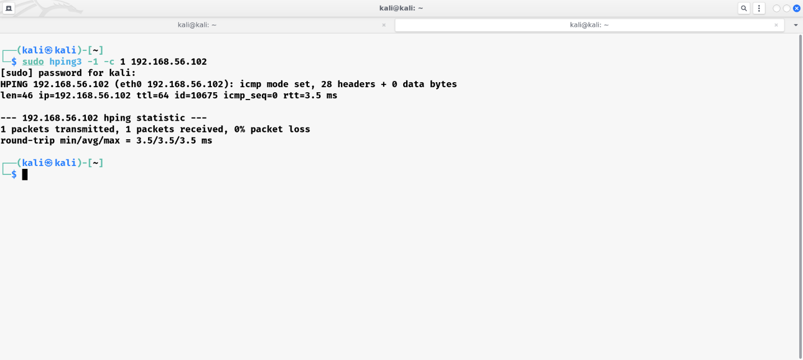

As we have sent packet to **192.168.56.102**, we will se this packet using wireshark.

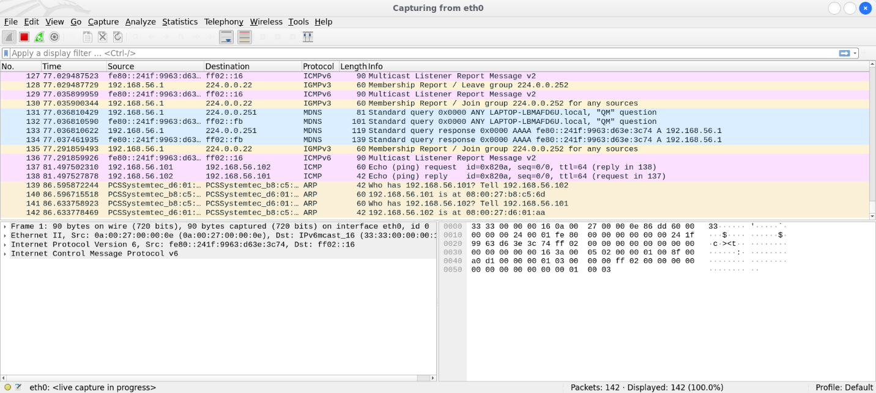

We can see there is echo request and echo reply.

Now we will increase the number of packets to be transmitted.

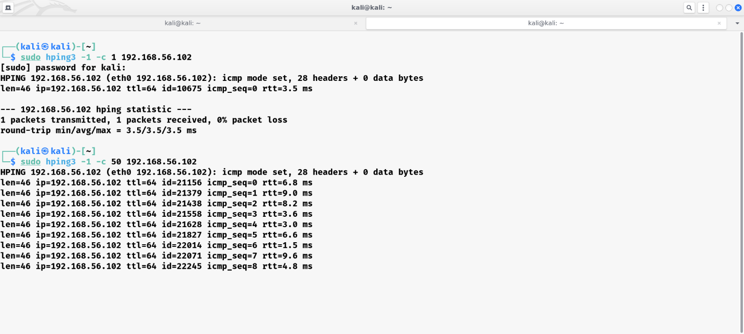

From above, we can see that now we are requesting **50** packet on same destination ip.

Now lets check the wireshark.

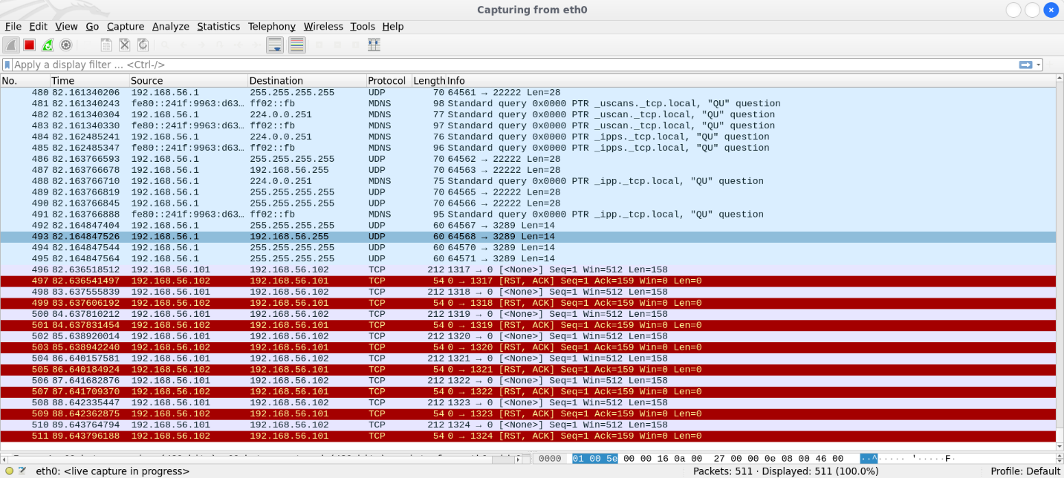

We can see packets in wireshark.

Now we will try to send packets from randon source ip to destination ip **192.168.56.102**

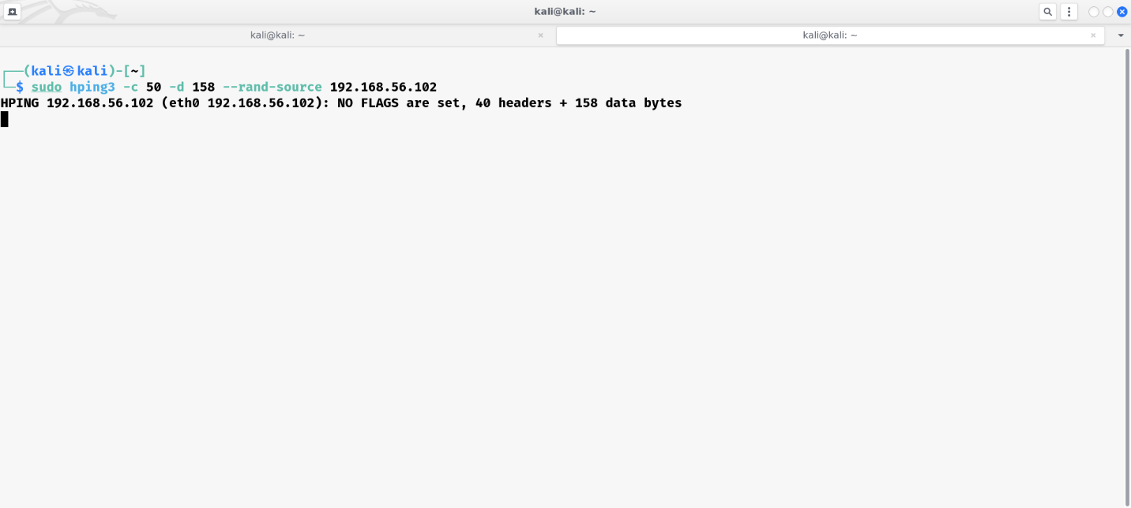

Now let’s see in wireshark

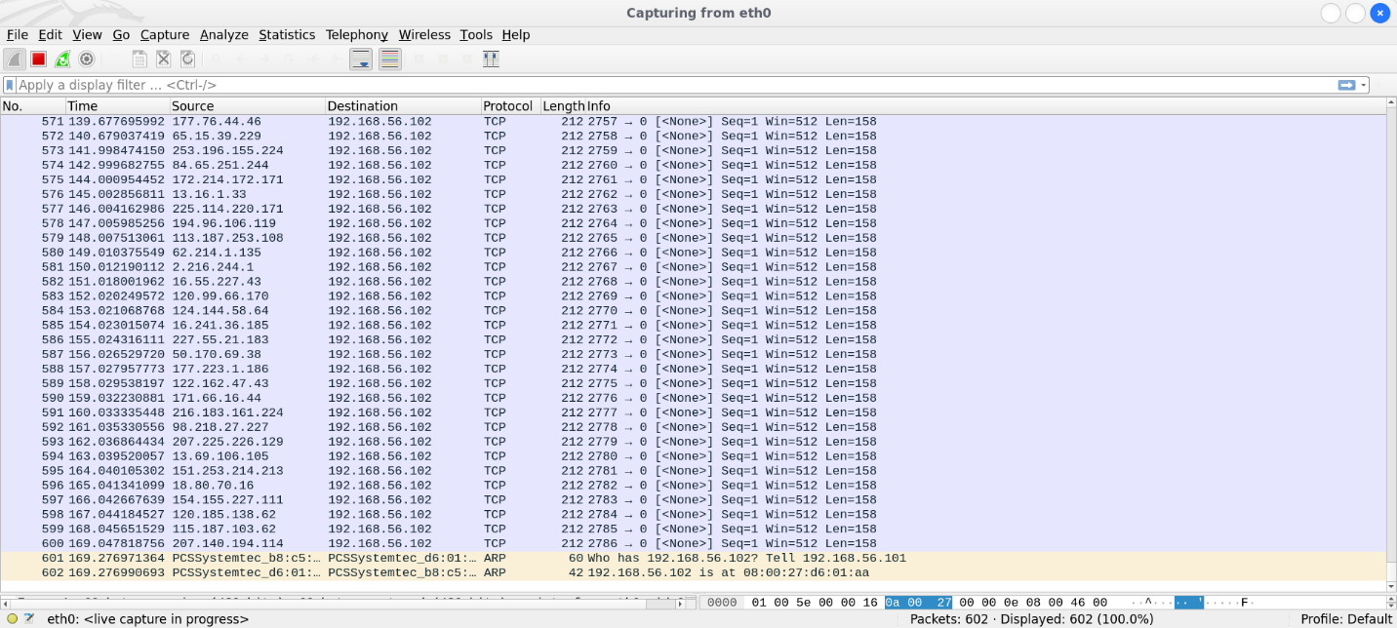

Now let’s send request from dummy ip**1.2.3.4**.

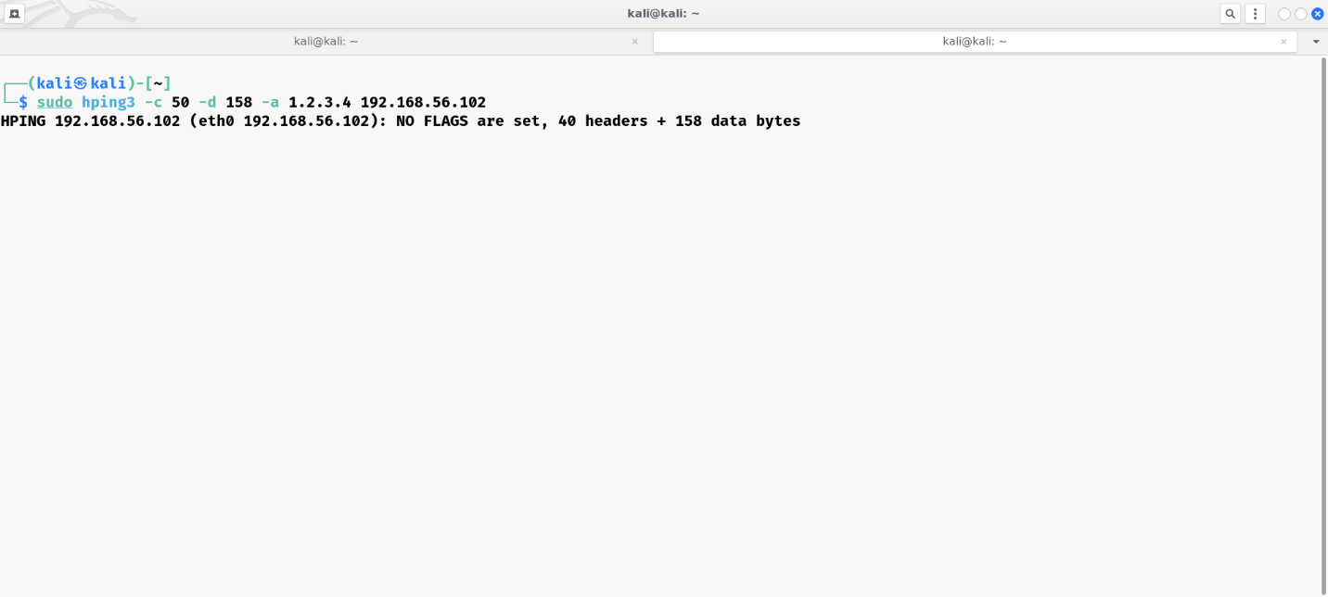

In wireshark :

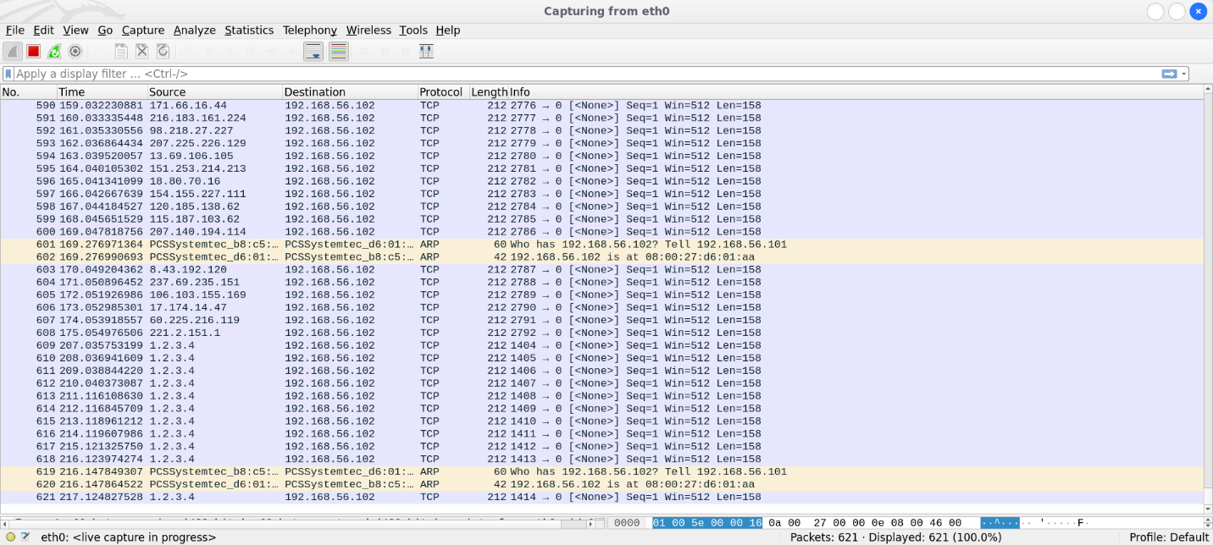

And at last, we will flooding to that ip address,

In flodding thousands of packets will be transmit to **192.168.56.102**

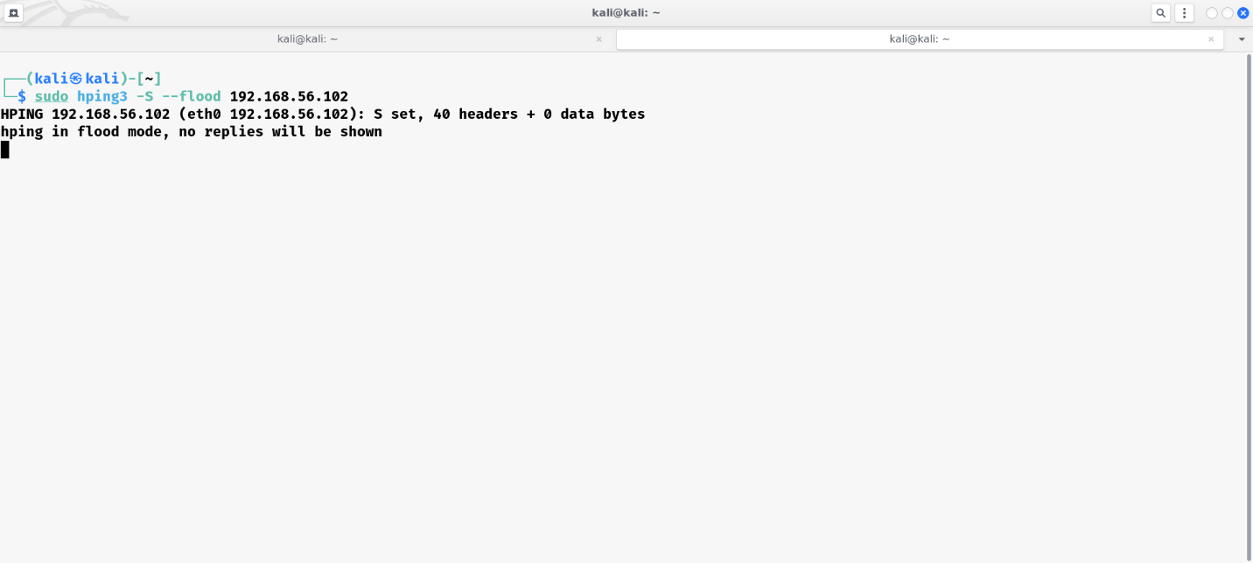

By using ***sudo hping3 -s –flood 192.168.56.102*** we will sendthousands of packets

In kali2 we can see packets from **192.168.56.101** are coming and it is coming very fast.

